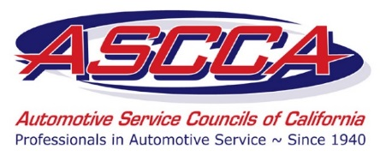

ASCCA Membership Liaison Program
Frequently Asked Questions

What is the ASCCA Membership Liaison Program?
Initiated by ASCCA’s Membership Committee, and approved by the Board of Directors, the purpose of this new endeavor is to gain and retain new members by cultivating relationships and emphasizing ASCCA membership value, advocacy efforts, and to provide business resources to its members. ASCCA Liaisons are independent contractors who will serve ASCCA’s membership growth and retention campaign by serving as association ambassadors, working to recruit and retain new members.

Who is eligible to apply to be an ASCCA Liaison?
Any individual who is not already an ASCCA member is eligible to apply to be an ASCCA Liaison. All applicants must be referred by a current ASCCA member or Corporate Partner, and submit an online application and questionnaire. ASCCA’s Executive Committee will review all potential candidates, and make the final decision on eligibility.

Do Liaisons need to attend training?
Yes, each new Liaison must participate in message training, either in person (to be held on select Team Weekends), or via online webinar. Travel costs for in-person meetings are not reimbursable.

What collateral materials will Liaisons receive?
Each new Liaison will receive ASCCA business cards with the core purpose on the back and a tri-fold leave-behind brochure with space to place a sticker label with the Liaison’s personal information. Each Liaison will also be provided an @ascca.com email address.

How much are ASCCA Liaisons compensated?
Each Liaison will receive a monthly compensation rate of $124 for each new member recruited up to 8 new members. As an extra incentive, any Liaison who recruits 9 or more members in one month will receive $201 per member. Liaisons who recruit at least 30 members in a year will receive a $50 bonus for any recruited members who renew the subsequent year. Liaisons who recruit at least 60 members in a year will receive a $100 bonus for any recruited members who renew.

When will Liaisons be compensated?
Payment periods will begin on the first day of each month, and will end on the last day of the month. Liaisons must report their compensation by the fifth day of the following month, and will then be paid no later than the 20th day of the month.

What is a Liaison’s contract length, and do Liaisons need to meet a recruitment quota?
Each contract agreement will be one year in length, and Liaisons must meet a minimum goal of no less than 30 new members by the end of each contract term.

Are there any incentives to recruit more than the minimum goal of 30?
Yes, any Liaison who recruits at least 60 members in each calendar year will receive “Elite Status” for the entire following year. Elite Liaisons will receive the following: ASCCA business cards noting their “Elite Status”, a standard $201 compensation for each new member recruited, and a $100 bonus for each renewing member that the Liaison recruited.

