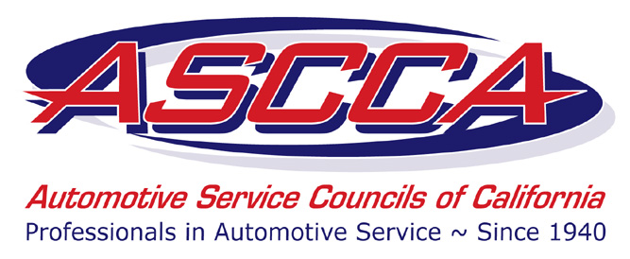

Board of Directors Candidate Application
ASCCA Board of Directors
Two (2) Year Term Commencing January 1, 2017

Eligibility Requirements
A Regular members of the ASCCA who meets the following criteria meets the minimum requirements for Board of Directors nomination consideration:
- Membership is current (in good standing)
- Has served in one of more of the following leadership positions; Chapter officer or a Chapter Representative or an ASCCA committee member.
- Submit completed Board of Directors Candidate Application by July 1, 2016.

Section I - Application (Please print legibly)

Name _________________________________________________________________ First MI Last Familiar name
Business Name: _________________________________________________________
Business Address: ________________________________________________________
Business City, State, Zip: __________________________________________________
Business Phone: ( ) _________________ Business Fax: ( ) _________________
E-Mail Address: _______________________________ Chapter #: ________________

Residence
Address: ___________________________________________________________
Phone: ______________________________ E-mail: ________________________

Section II - Candidate Profile
Business Information (type of business, years in business, years in that location, etc.)
_______________________________________________________________________

ASCCA Activities (Number of years you have been a member, chapter activities and positions held, state level activities and positions held, etc.).
_______________________________________________________________________
_______________________________________________________________________
_______________________________________________________________________

List boards and committees that you serve on, or have served on for other organizations (business, civic, community, fraternal, political, professional, recreational, religious, social).

Organization Role/Title Dates of Service
_______________________________________________________________________
_______________________________________________________________________
_______________________________________________________________________
_______________________________________________________________________

Personal Information (Years involved in the automotive industry, family information you wish to divulge, hobbies, civic activities, professional activities/affiliations, memberships in other fraternal and/or civic organizations, etc.).
_______________________________________________________________________
_______________________________________________________________________
_______________________________________________________________________

Education/Training/Certificates
_______________________________________________________________________
_______________________________________________________________________
_______________________________________________________________________

Optional – Have you received any awards or honors that you’d like to mention?
_______________________________________________________________________
_______________________________________________________________________
_______________________________________________________________________

How do you feel ASCCA would benefit from your involvement on the Board?
_______________________________________________________________________
_______________________________________________________________________
_______________________________________________________________________

Skills, experience and interests (Please circle all that apply)

Finance, accounting  Personnel, human resources  Administration, management  Nonprofit experience  Community service  Policy development  Program evaluation  Public relations, communications | Education, instruction  Special events  Grant writing  Fundraising  Outreach, advocacy  Other _______________________  Other _______________________  Other _______________________

Please list any groups, organizations or businesses that you could serve as a liaison to on behalf of ASCCA.
_______________________________________________________________________
_______________________________________________________________________
_______________________________________________________________________

Please tell us anything else you’d like to share.
_______________________________________________________________________
_______________________________________________________________________
_______________________________________________________________________

Submit completed application by e-mail to
Gloria Peterson, gpeterson@amgroup.us or fax to (916) 444-7462.
Completed forms must be received on or before July 1, 2016.

