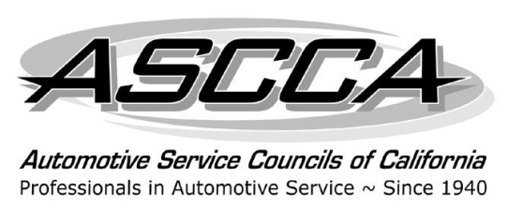
Automotive Service Councils
of California
For additional information contact: Gloria Peterson
One Capitol Mall, Suite 320
Sacramento, CA 95814-3229
(916) 924-9054
We support ASE
(800) 810-4272
FAX (916) 444-7462
E-mail: gpeterson@amgroup.us

For Immediate Release
ASCCA Past President Allen Pennebaker Elected NASTF Chair

Sacramento, CA, December 11, 2013—The Automotive Service Councils of California (ASCCA), the pre-eminent trade association for the independent automotive repair industry in California, congratulates Past President Allen Pennebaker, owner of Orinda Motors in Orinda, on his election as Chair, Board of Directors, of the National Automotive Service Task Force (NASTF). Assuming the position in January, he is the first independent shop owner chair since NASTF’s founding in 2000. Mr. Pennebaker has served on the NASTF Board for many years as a representative of the independent automotive repair industry. A change in the Bylaws in early 2013 allowed for industry-wide nominations and open elections for 2014.

Mr. Pennebaker served as ASCCA President in 2008 and has continued his active participation in the organization as Past President and ex-officio to the Board of Directors. He is also active in ASCCA Chapter 20, in the East Bay.
NASTF was established in 2000 to identify, communicate and resolve gaps in the availability and accessibility of automotive service information, service training, diagnostic tools, and equipment for the benefit of automotive service professionals and their customers.

Founded in 1940, the Automotive Service Councils of California is the largest independent automotive repair organization in California. Its members represent all areas of the automotive repair industry, including mechanical, auto body, suppliers and educators.

"To elevate and Unite Automotive Professionals, and give them a voice. “

